TUTORIAL 10
Module Name: Regression Testing – SauceDemo Website
REG01: Login
Test Case ID: REG01
Test Scenario: Verify login functionality
Steps:
  - Open SauceDemo.
  - Enter valid username.
  - Enter valid password.
  - Click Login.
Screenshot: 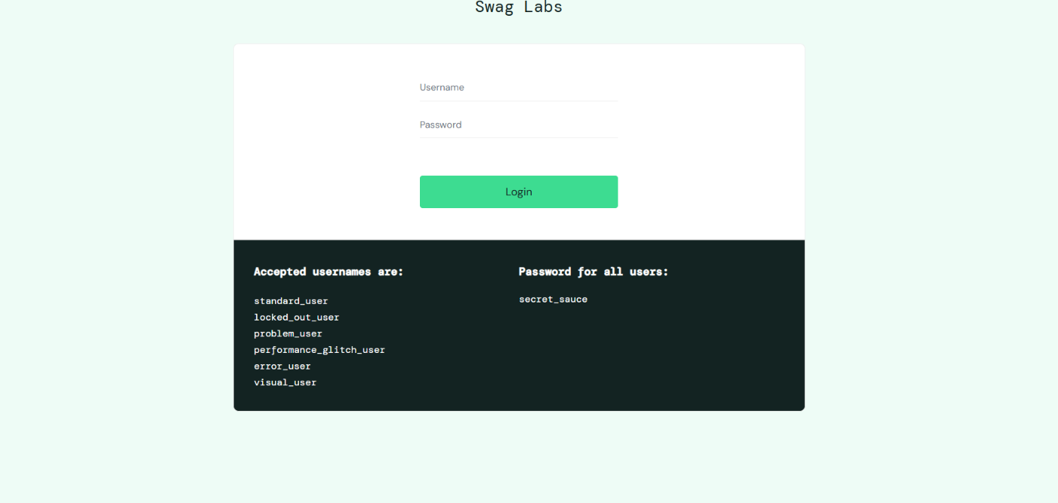
Expected Result: User should successfully log in and the product page should open.
Actual Result:
Status: Pass

REG02 – Product Display
Test Case ID: REG02
Test Scenario: Verify Product Display
Steps:
- Open SauceDemo website.
- Enter valid login credentials.
- Click on Login.
- Verify the product listing page.
Screenshot: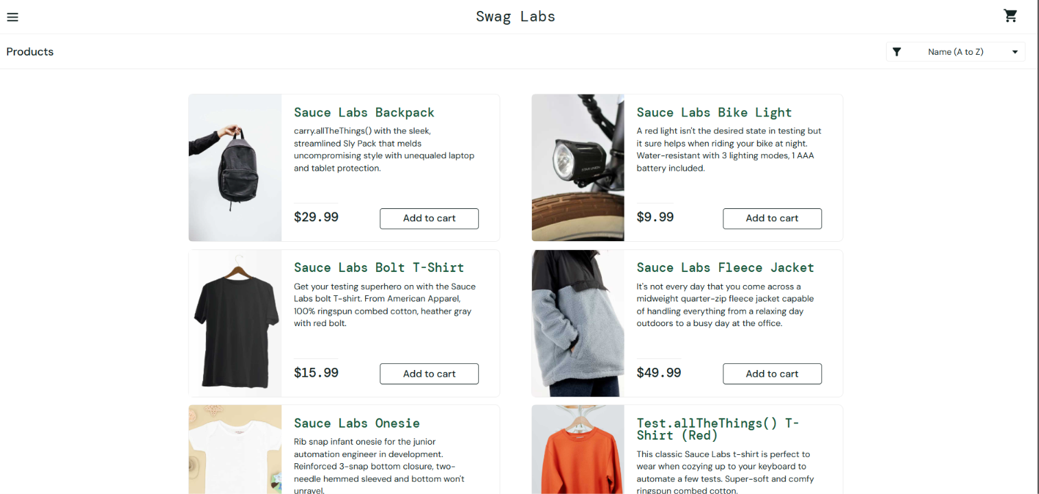
Expected Result: Products should be displayed with names, images, prices, and Add to Cart buttons.
Actual Result: Products were displayed with names, images, prices, and Add to Cart buttons.
Status: Pass

REG03 – Add to Cart
Test Case ID: REG03
Test Scenario: Verify Add to Cart
Steps:
- Open SauceDemo website.
- Enter valid login credentials.
- Click on Login.
- Click on Add to Cart for a product.
- Verify the cart badge.
Screenshot: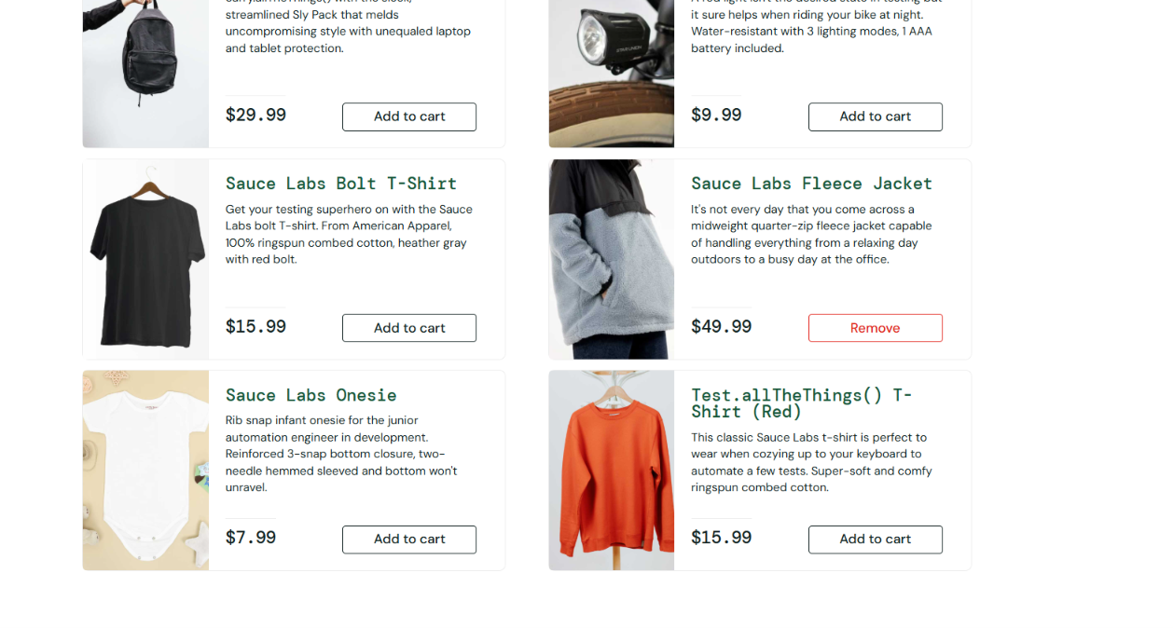
Expected Result: The selected product should be added to the cart.
Actual Result: The selected product was added to the cart.
Status: Pass

REG04 – Remove from Cart
Test Case ID: REG04
Test Scenario: Verify Remove from Cart
Steps:
- Open SauceDemo website.
- Login with valid credentials.
- Add a product to the cart.
- Click on the Remove button.
- Verify the cart badge.
Screenshot: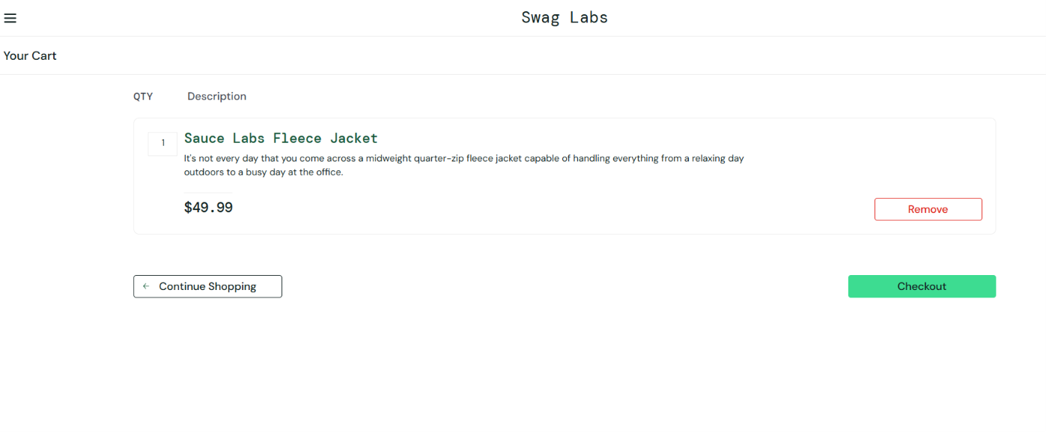
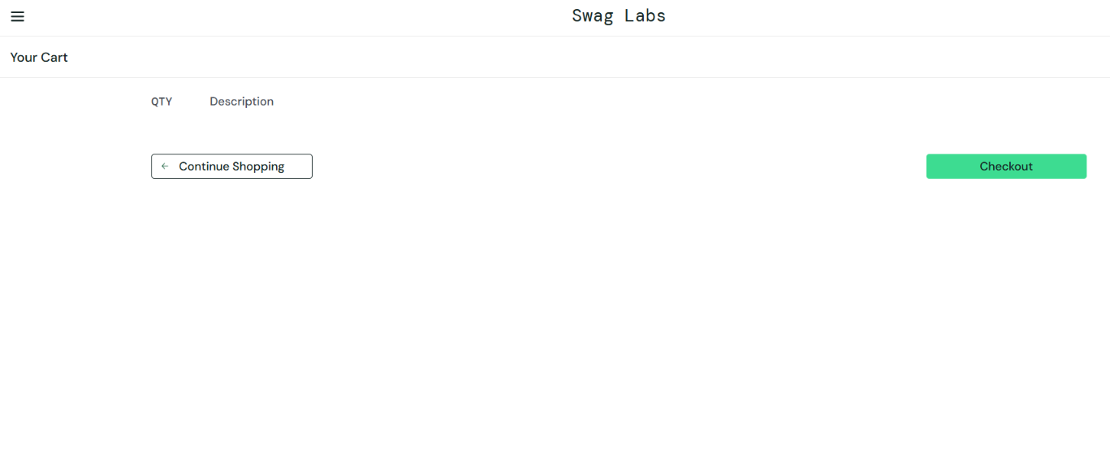
Expected Result: The selected product should be removed from the cart, and the cart badge should disappear.
Actual Result: The selected product was removed from the cart, and the cart badge disappeared.
Status: Pass

REG05 – Checkout
Test Case ID: REG05
Test Scenario: Verify Checkout
Steps:
- Open SauceDemo website.
- Login with valid credentials.
- Add a product to the cart.
- Open the cart and click Checkout.
- Enter First Name, Last Name and Postal Code.
- Click Continue.
- Verify the checkout overview page.
Screenshot: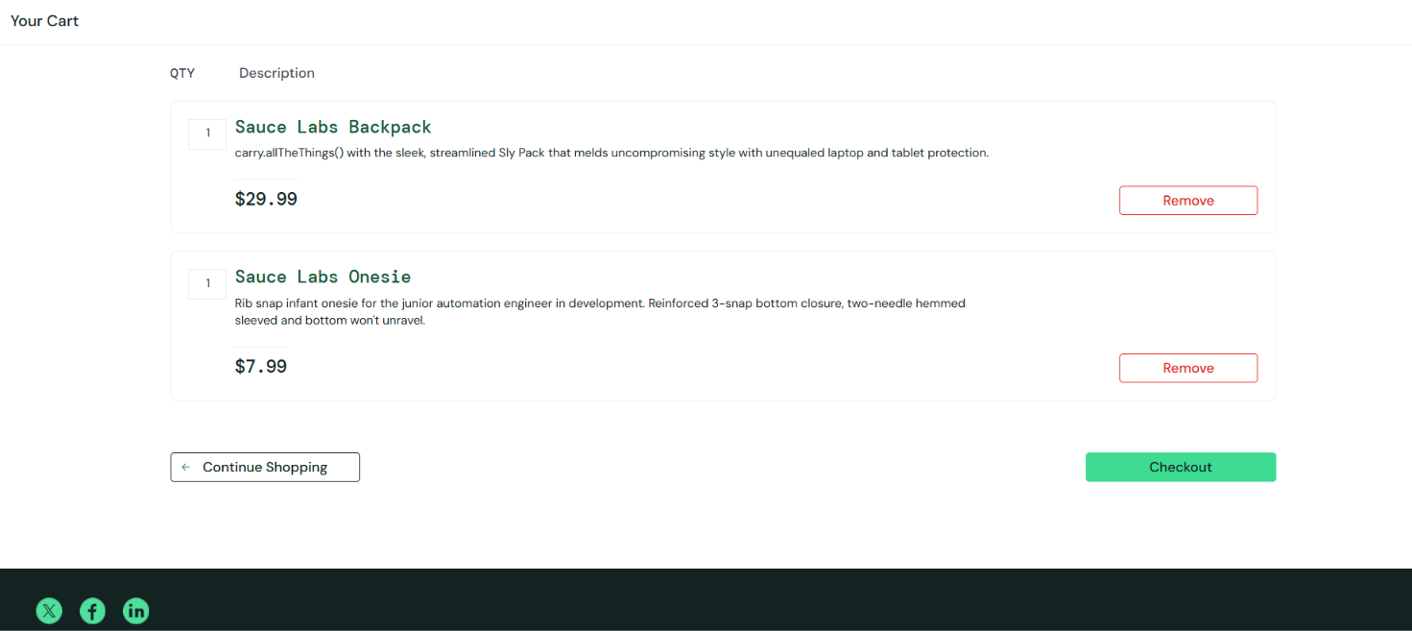

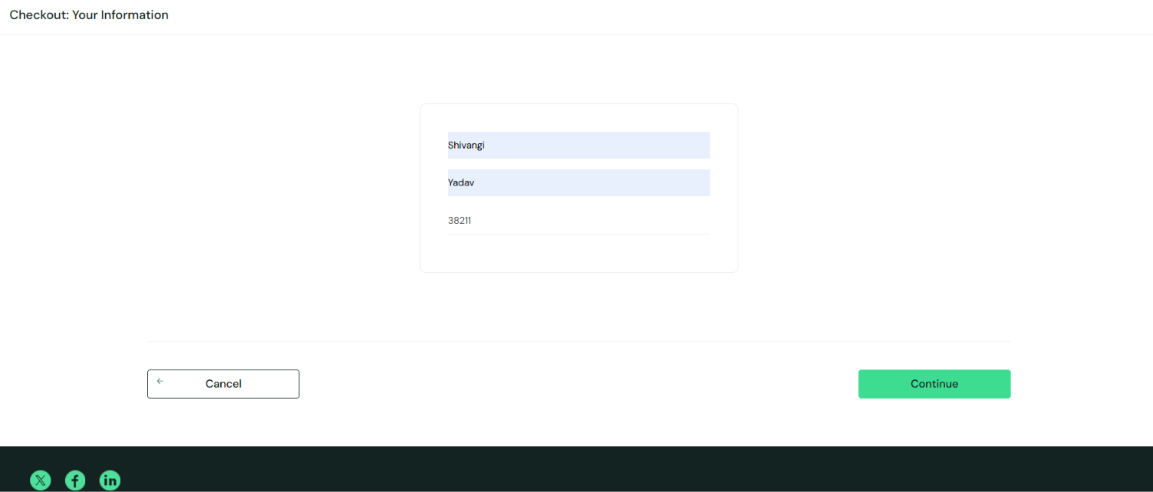
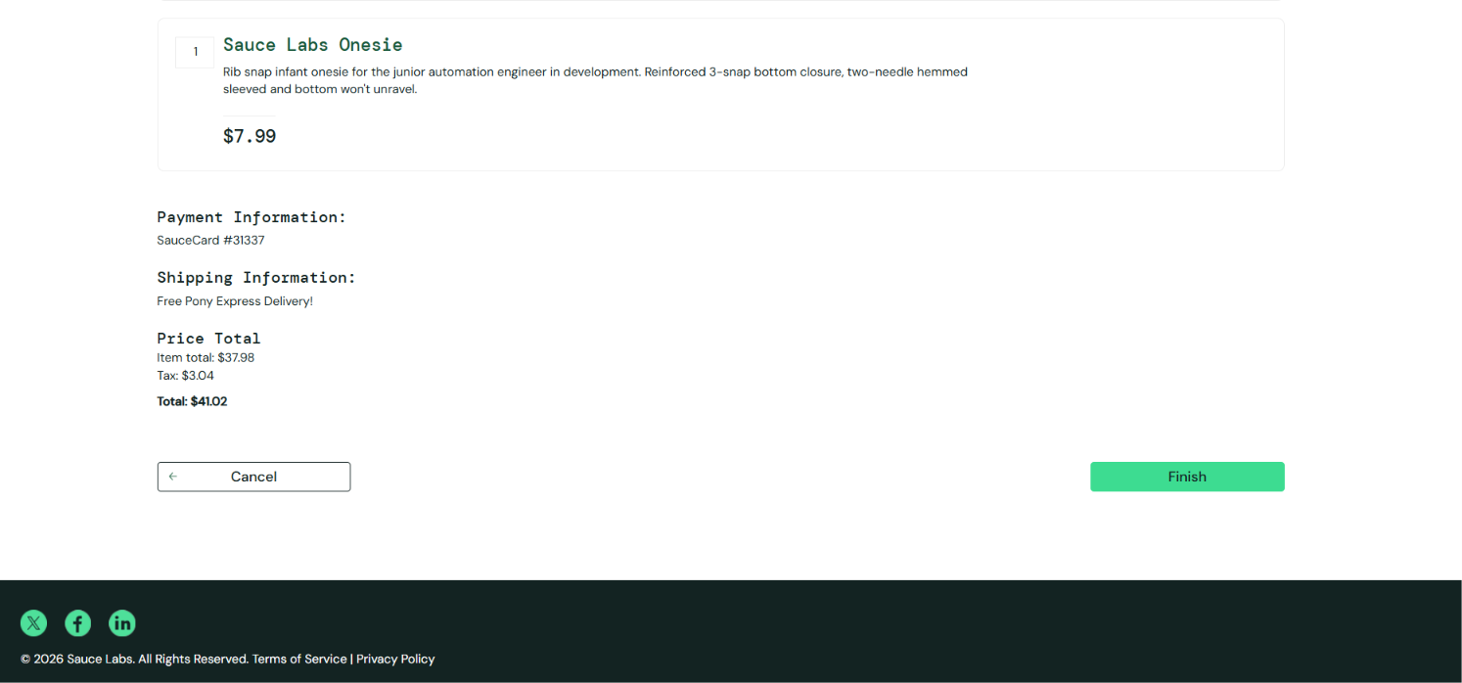
Expected Result: The checkout overview page should display the selected product, price and order summary.
Actual Result: The checkout overview page displayed the selected product, price and order summary.
Status: Pass

REG06 – Logout
Test Case ID: REG06
Test Scenario: Verify Logout
Steps:
- Open SauceDemo website.
- Login with valid credentials.
- Click on the menu icon.
- Click on Logout.
- Verify the login page.
Screenshot: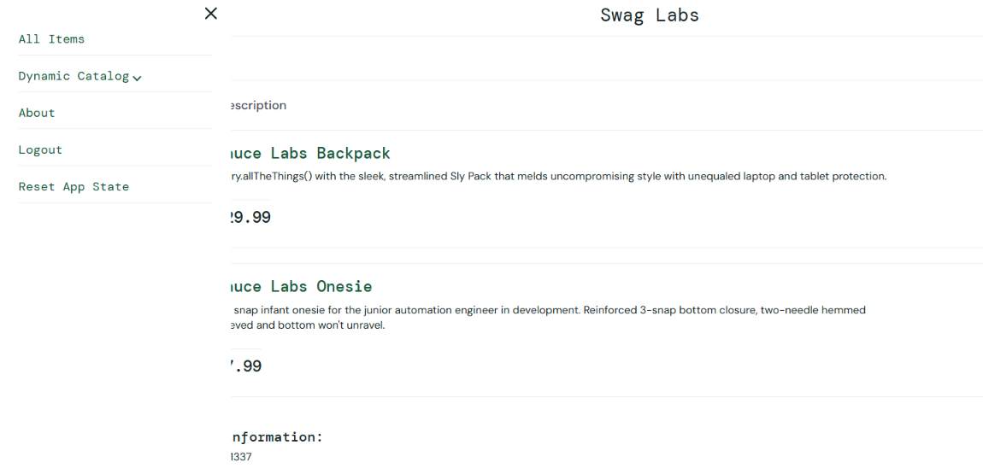
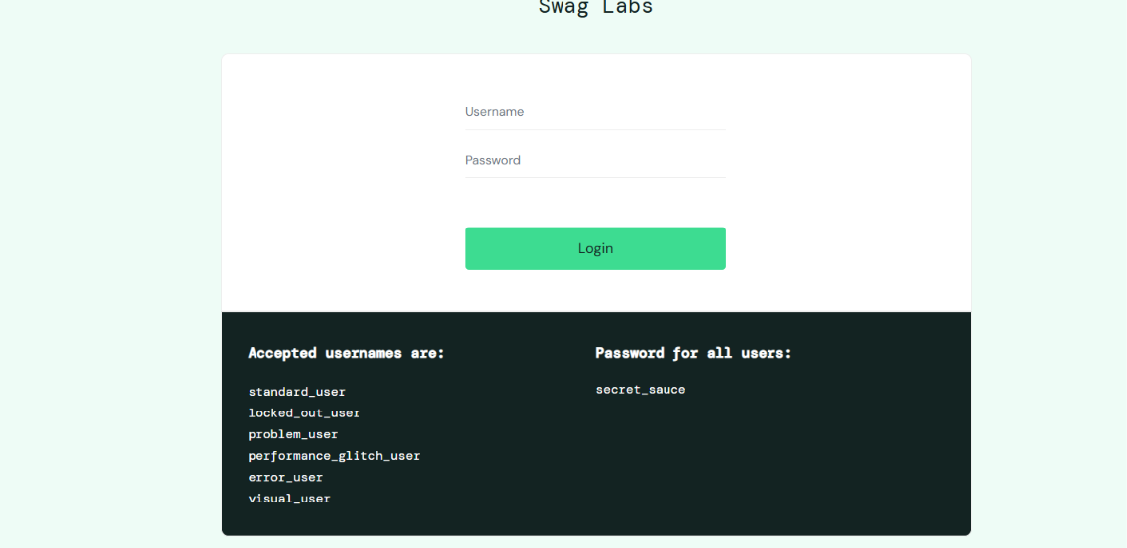
Expected Result: The user should be logged out successfully, and the login page should be displayed.
Actual Result: The user was logged out successfully, and the login page was displayed.
Status: Pass

Conclusion
The regression testing of the SauceDemo website was completed to verify the main functionalities, including Login, Product Display, Add to Cart, Remove from Cart, Checkout, and Logout. Each test case was executed to check whether the actual results matched the expected results. The testing helped verify the website's basic functionality and identify any issues. Overall, the website worked as expected for the test cases that passed.

